CA-1 (Source Code)

Name: Shivang Chaurasia
Roll No: 25

Question 1:
Source Code:
import java.util.*;
import java.util.stream.Collectors;

class Student {
String name;
String stream;
String department;
double cgpa;

public Student(String name, String stream, String department, double cgpa) {
this.name = name;
this.stream = stream;
this.department = department;
this.cgpa = cgpa;
}

public String getName() {
return name;
}

public String getDepartment() {
return department;
}

public double getCgpa() {
return cgpa;
}

@Override
public String toString() {
return name + " (" + cgpa + ")";
}
}

public class Q1_Streams {
public static void main(String[] args) {
List<Student> students = Arrays.asList(
new Student("Aman", "BTech", "CSE", 8.5),
new Student("Aditya", "BTech", "IT", 7.5),
new Student("Chandan", "BTech", "CSE", 9.0),
new Student("Shivang", "BTech", "ECE", 6.8),
new Student("Uday", "BTech", "ME", 8.2));

Map<Boolean, List<Student>> reportA = students.stream()
.collect(Collectors.partitioningBy(s -> s.getCgpa() > 8.0));

System.out.println("--- Report A: CGPA > 8.0 ---");
System.out.println("Score > 8.0: " + reportA.get(true));
System.out.println("Score <= 8.0: " + reportA.get(false));

Map<String, List<Student>> reportB = students.stream()
.collect(Collectors.groupingBy(s -> s.getDepartment()));

System.out.println("\n--- Report B: Group by Department ---");
reportB.forEach((dept, list) -> System.out.println(dept + ": " + list));

Map<String, List<String>> reportBNames = students.stream()
.collect(Collectors.groupingBy(
s -> s.getDepartment(),
Collectors.mapping(s -> s.getName(), Collectors.toList())));

System.out.println("\n--- Modified Report B: Department with Names only ---");
reportBNames.forEach((dept, names) -> System.out.println(dept + ": " + names));
}
}

// Explain why partitioningBy()is inappropriate for Report B?
// Ans: because it is designed to split a collection into two groups based on a boolean predicate.
// In the case of Report B, we want to group students by their department, which can have multiple categories (e.g., CSE, IT, ECE, ME). ns (true and false). Instead, `groupingBy()` is the correct choice for this scenario, as it allows us to group elements based on a key (in this case, the department) and can handle multiple categories effectively.

// Modify Report B so each department contains only students names?
// Ans: To modify Report B so that each department contains only the names of the students, we can use the `Collectors.mapping()`
// collector in conjunction with `Collectors.groupingBy()`.
// This allows us to transform the list of students into a list of their names while still grouping them by department.

Output:
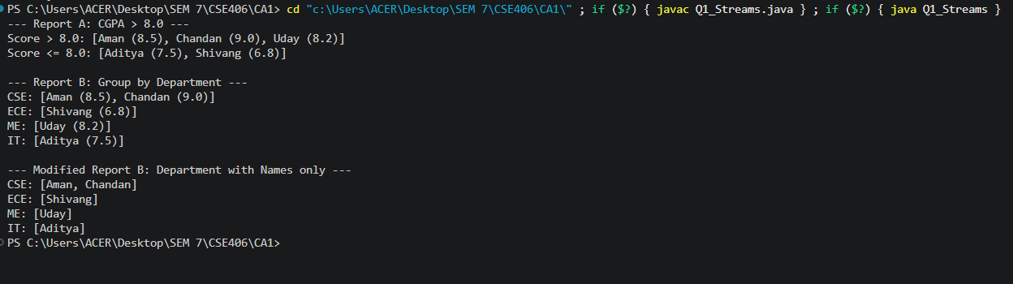

Question 2:
Source Code:
import javax.swing.*;
import java.awt.*;
import java.awt.event.*;

public class SimpleCalculator {
static double num1 = 0, num2 = 0;
static String operator = "";

public static void main(String[] args) {
JFrame frame = new JFrame("Simple Calculator");
frame.setLayout(new FlowLayout());

JTextField display = new JTextField(15);
JLabel resultLabel = new JLabel("Result: 0");

frame.add(display);
frame.add(resultLabel);

for (int i = 0; i <= 9; i++) {
String digit = String.valueOf(i);
JButton numBtn = new JButton(digit);
numBtn.addActionListener(new ActionListener() {
public void actionPerformed(ActionEvent e) {
display.setText(display.getText() + digit);
}
});
frame.add(numBtn);
}

JButton btnPlus = new JButton("+");
JButton btnMinus = new JButton("-");
JButton btnMul = new JButton("*");
JButton btnDiv = new JButton("/");
JButton btnEqual = new JButton("=");
JButton btnClear = new JButton("C");

frame.add(btnPlus);
frame.add(btnMinus);
frame.add(btnMul);
frame.add(btnDiv);
frame.add(btnEqual);
frame.add(btnClear);

btnPlus.addActionListener(new ActionListener() {
public void actionPerformed(ActionEvent e) {
if (!display.getText().isEmpty()) {
num1 = Double.parseDouble(display.getText());
operator = "+";
display.setText("");
resultLabel.setText("Operator: +");
}
}
});

btnMinus.addActionListener(new ActionListener() {
public void actionPerformed(ActionEvent e) {
if (!display.getText().isEmpty()) {
num1 = Double.parseDouble(display.getText());
operator = "-";
display.setText("");
resultLabel.setText("Operator: -");
}
}
});

btnMul.addActionListener(new ActionListener() {
public void actionPerformed(ActionEvent e) {
if (!display.getText().isEmpty()) {
num1 = Double.parseDouble(display.getText());
operator = "*";
display.setText("");
resultLabel.setText("Operator: *");
}
}
});

btnDiv.addActionListener(new ActionListener() {
public void actionPerformed(ActionEvent e) {
if (!display.getText().isEmpty()) {
num1 = Double.parseDouble(display.getText());
operator = "/";
display.setText("");
resultLabel.setText("Operator: /");
}
}
});

btnEqual.addActionListener(new ActionListener() {
public void actionPerformed(ActionEvent e) {
if (!display.getText().isEmpty() && !operator.isEmpty()) {
num2 = Double.parseDouble(display.getText());
double result = 0;

if (operator.equals("+")) result = num1 + num2;
else if (operator.equals("-")) result = num1 - num2;
else if (operator.equals("*")) result = num1 * num2;
else if (operator.equals("/")) result = (num2 != 0) ? (num1 / num2) : 0;

display.setText(String.valueOf(result));
resultLabel.setText("Result: " + result);
operator = "";
}
}
});

btnClear.addActionListener(new ActionListener() {
public void actionPerformed(ActionEvent e) {
display.setText("");
resultLabel.setText("Result: 0");
num1 = 0;
num2 = 0;
operator = "";
}
});

display.addKeyListener(new KeyAdapter() {
public void keyPressed(KeyEvent e) {
if (e.getKeyCode() == KeyEvent.VK_ESCAPE) {
display.setText("");
resultLabel.setText("Result: 0");
num1 = 0;
num2 = 0;
operator = "";
}
}
});

frame.addWindowListener(new WindowAdapter() {
public void windowClosing(WindowEvent e) {
System.exit(0);
}
});

btnPlus.addMouseListener(new MouseAdapter() {
public void mouseEntered(MouseEvent e) {
resultLabel.setText("Mouse entered + button");
}
});

frame.setSize(220, 300);
frame.setVisible(true);
}
}

Output:
